Thanks for downloading my Bookmarks and Cross-References practice document! Here, you can find illustrated the three techniques for cross-referencing a paragraph into another paragraph:
Scenario #1: Using automatic paragraph numbers to drive cross-references. This is the simplest way to cross-reference: Just use automatic paragraph numbering to number your paragraphs, then insert bookmarks back to whichever paragraph you’re referring to.
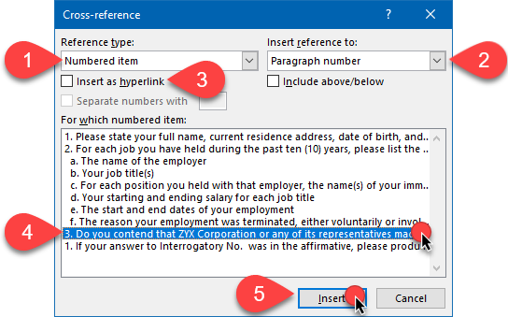
Scenario #2: Bookmarking manual paragraph numbers. If you don’t use automatic paragraph numbering, you can still cross-reference paragraph numbers; you’ll just have to insert a bookmark first, then insert a cross-reference to that bookmark:
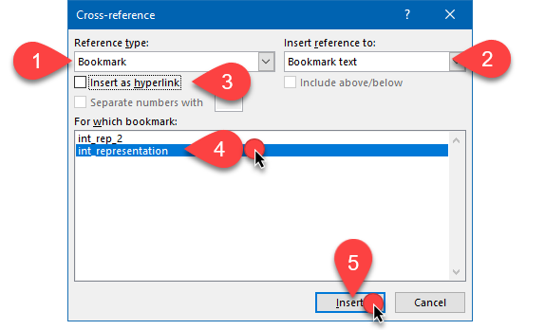
Scenario #3: Creating SEQ fields to generate independent, interspersed numbering schemes and cross-referencing those numbers elsewhere in your document. Here’s a third, optional technique in case you need to intersperse different numbering schemes among each other. Hint: If you want to see the “guts” of the SEQ fields, press ALT-F9 (press it again to return to normal display):
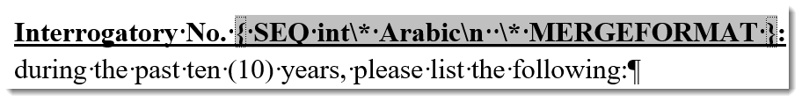

Happy experimenting!

INTERROGATORIES
- Please state your full name, current residence address, date of birth, and Social Security number.
- For each job you have held during the past ten (10) years, please list the following:
  - The name of the employer
  - Your job title(s)
  - For each position you held with that employer, the name(s) of your immediate supervisor(s) and the job title(s) of each immediate supervisor
  - Your starting and ending salary for each job title
  - The start and end dates of your employment
  - The reason your employment was terminated, either voluntarily or involuntarily.
- Do you contend that ZYX Corporation or any of its representatives made any representations to you that your television was in fact covered under the manufacturer’s warranty?

REQUESTS FOR PRODUCTION OF DOCUMENTS
- If your answer to Interrogatory No. 3 was in the affirmative, please produce all documents, including but not limited to correspondence, emails, agreements, contracts, audio recordings, transcriptions, and notes evidencing such representations.

INTERROGATORIES
1. Please state your full name, current residence address, date of birth, and Social Security number.
2. For each job you have held during the past ten (10) years, please list the following:
a. The name of the employer
b. Your job title(s)
c. For each position you held with that employer, the name(s) of your immediate supervisor(s) and the job title(s) of each immediate supervisor
d. Your starting and ending salary for each job title
e. The start and end dates of your employment
f. The reason your employment was terminated, either voluntarily or involuntarily.
3. Do you contend that ZYX Corporation or any of its representatives made any representations to you that your television was in fact covered under the manufacturer’s warranty?

REQUESTS FOR PRODUCTION OF DOCUMENTS
1. If your answer to Interrogatory No. 3 was in the affirmative, please produce all documents, including but not limited to correspondence, emails, agreements, contracts, audio recordings, transcriptions, and notes evidencing such representations.

Interrogatory No. 1: Please state your full name, current residence address, date of birth, and Social Security number.
Interrogatory No. 2: For each job you have held during the past ten (10) years, please list the following:
a. The name of the employer
b. Your job title(s)
c. For each position you held with that employer, the name(s) of your immediate supervisor(s) and the job title(s) of each immediate supervisor
d. Your starting and ending salary for each job title
e. The start and end dates of your employment
f. The reason your employment was terminated, either voluntarily or involuntarily.
Interrogatory No. 3: Do you contend that ZYX Corporation or any of its representatives made any representations to you that your television was in fact covered under the manufacturer’s warranty?
Request for Production 1: If your answer to Interrogatory No. 3 was in the affirmative, please produce all documents, including but not limited to correspondence, emails, agreements, contracts, audio recordings, transcriptions, and notes evidencing such representations.

